**CHAT AND CONFERENCING**

**2. Virtual meetings**

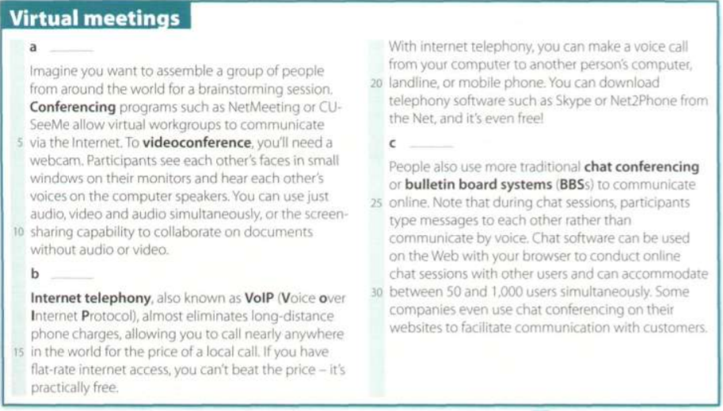

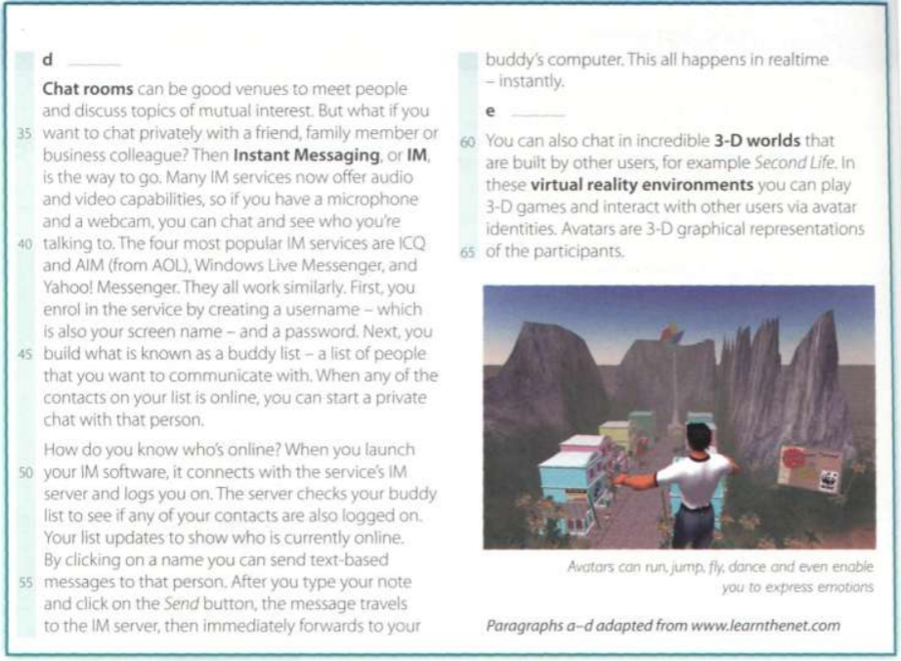

**A. Read the text and match the headings (1-5) with the gaps at the start of each paraghaph (a-e).**

1 b Cheap calls over the internet.

2 e Virtual words and online communities.

3 c Chat rooms on the Web: join the crowd!

4 a Real-time videoconferencing.

5 d Private chats with IM services.

**B. Read the text again and answer these questions.**

1 Why is videoconferencing so useful for virtual workgroups?

Allows virtual workgroups to communicate easily over long distances; They can exchange ideas and information

2 What special hardware and software do you need to videoconference?

A webcam and a conferencing program.

3 Which technology enables people to make phone calls over the Internet?

Internet telephony, also known as VoIP.

4 What is the difference between web chat rooms and Instant Messaging?

Web chat rooms allow multiple users to join a conversation and see what everyone else is writing. They are based on certain themes. Instant messaging serves for a private conversation between two people or a more specific group. How can they be friends, workgroup, etc.

5 How do you log on to an IM server?

With a username and password.

**C. Find terms in the text with the following meanings.**

1 at a fixed price (lines 15-20)

flat-rate

2 a central system that provides information about whether users are online and passes instant messages between therm (lines 35-40)

Instant Messaging (IM)

3 a friend list or contact list (lines 45-50)

Buddy list

4 happening immediately and without delay (line 55-60)

in real time

5 artificial reality: a 3-D space generated by the computer (lines 60-65)

virtual reality

6 characters use whem interacing with people online (lines 60-65)

avatars

**4. R u free 4 a chat?**

**A. Rewhite this IM chat, using full forms instead of abbreviations. Then look at the Help box on page 92 to check your answers.**

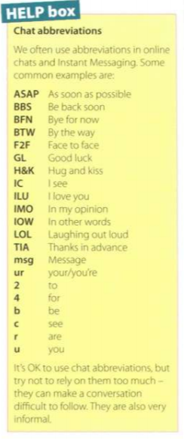

Abby: BTW, where r u going for ur holiday?

By the way, where are you going for you holiday?

Sue: Girona. Have u been?

Girona. Have you been?

Abby: Yes. I went 2 Girona last summer.

Yes. I went to Girona last summer

Sue: Did u have a good time?

Did you have a good time?

Abby It’s great, IMO. How r u going 2 travel?

It's great, in my opinion. How are you going to travel?

Sue. We're flying.

Were flying.

Abby Where r u staying?

Where are you staying?

Sue In a youth hostel.

In a youth hostel.

Abby IC. IOW, the cheapest place possible!

I see. In other words, the cheapest place possible!

Sue: LOU Yes. BTW. any recommendations?

Laughing out loud! Yes. By the way, any recommendations?

Abby: Let me think. I'll send u a msg ASAP.

Let me think Ill send you a message as soon as possible

Sue. TIAI!

Thanks in advance.

Abby: Got 2 go. BFN!

Got to go. Bye for now!

**B Rewhite this IM chat using abbreviations.**

Paulo: By the way , are you free on Saturday?

BTW, r u free on Saturday?

Emma: Sure- it would be good to meet face to face. Shall we go for a coffe?

Sure - it would b good 2 meet F2F. Shall we go 4 a coffee?

Paulo: Good plan. Café Moka makes the best coffee, in my opinion.

Good plan. Cafe Moka makes the best coffee, IMO

Emma: It’s the closest to your house in the others words.

It's the closest 2 ur house IOW!

Paulo: Laughing out loud! Yes, you’re right! But the coffe really is good.

La! Yes, ur right! But the coffee really is good

Emma: See you at 4?

C uat 4?

Paulo: Great. Bye for now.

Great. BFN

**D In pairs, discuss thes questions. Give reasons for your answers.**

1 Which program do you use to chat with friends?

Whatsapp, is a mobile application.

2 Do you use abbreviations when you chat online or when you send text messages?

No, when I was younger in the sms yes. Because of its limitation of characters per message.

3 Do you use voice or video while chatting? How?

No, the unlimited calling rates nowadays are cheap.

4 Have you ever used the Internet to make cheap calls?

Yes, only for international calls.

5 Does Instant Messaging distract you from work?

Yes, especially the WhatsApp application.

6 Do you use your real name or a nickname in chat rooms?

No, I use a nickname.

7 Do you talk to strangers during web chats? Why shouldn't you?

Yes, but only that.

8 Would you ever go on a date with somebody you'd me on the Net?

No, and if it did, it would be in public places with a lot of people around.

**5. At a cybercafé**

**B. Listen to an interview with Daniel Sturdy, the manager of a cybercafé in London. Does like where he works?**

Yes, he says it’s the kind of place he’d like to spend time even if the didn’t work there.

**C. Listen again and decide whether these sentences are these are true or false. Correct the false ones.**

1 A cybercafé is a café where you can have access to the Internet and related services.

True

2 You can talk to people over the Internet using internet telephony at Daniel’s café.

True

3 They don’t help people who have problems while using the Internet.

False- They do help people if they have problems. For beginners, they give tutorial.

4 Using a computer with Internet access costs £2 per hour or £80 for week.

False- Oneweek is £18

5 At the moment they’ve got a lot of International customers.

True

6 You have to pay long-distance phone rates on the Internet.

False- You don’t have to pay long-distance phone rates on the Internet.

7 In the café area yiu can sit, drink coffee and chat to people.

True